**Glossary Tool**

Introducing our Glossary Tool application that provides users with a convenient way to explore more information about a word with just a double-click. With this incredible tool, users can access a wide range of resources. These include definitions, synonyms, antonyms, homonyms, and abbreviations. Additionally, you can find translations into your preferred language, videos, images, and even the pronunciation of the word.

This is a comprehensive guide on how to use this application effectively. Our aim is to help you maximize your user experience by offering flexibility to customize the tool according to your preferences.

**How to Use the Application**

Step 1:

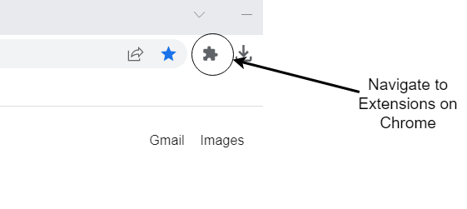

Step 2:

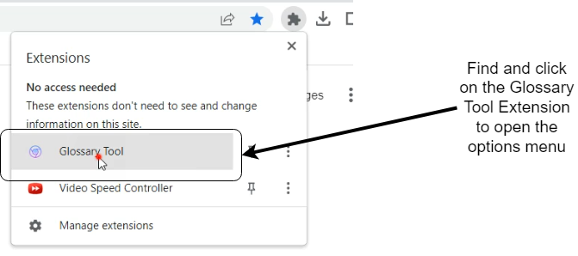

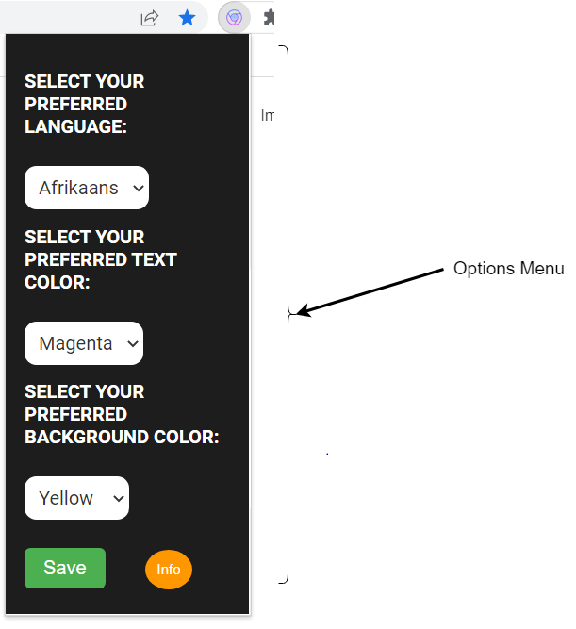

Step 3:

Note: If the translation language is not selected, Afrikaans is the default language

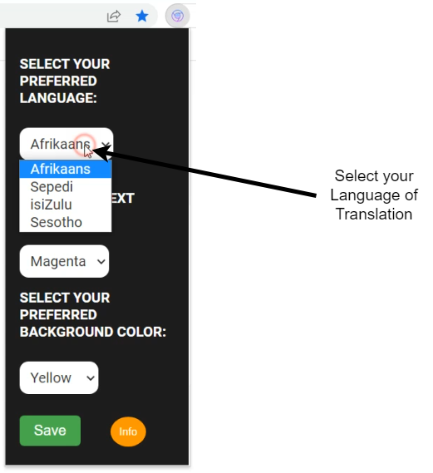

Step 4:

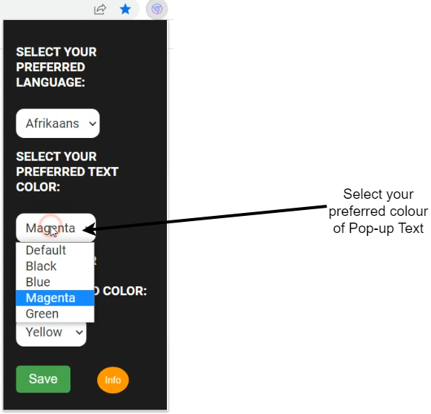

Step 5:

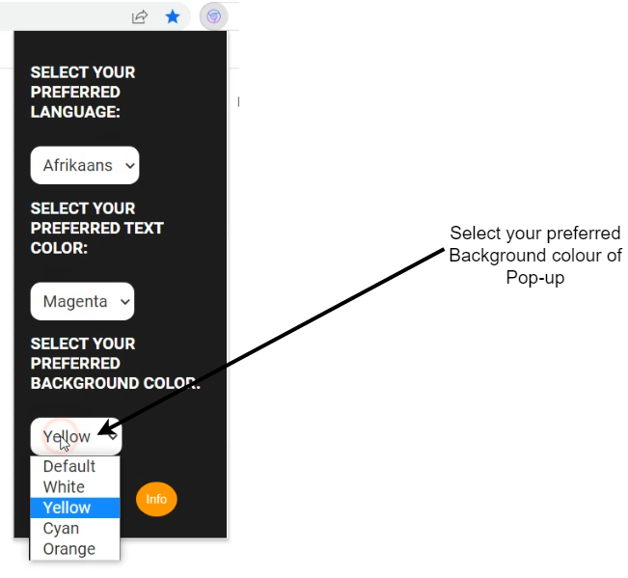

Step 6:

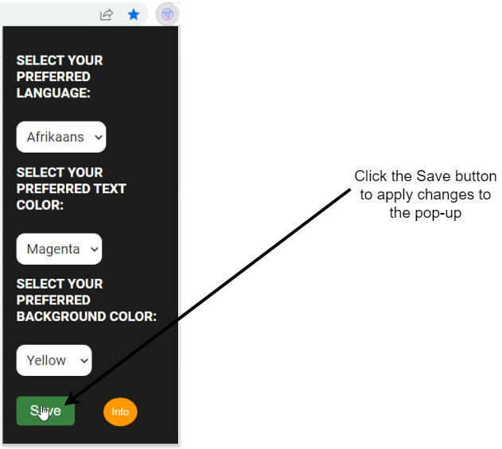

Step 7:

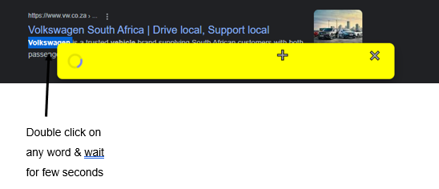

Step 8:

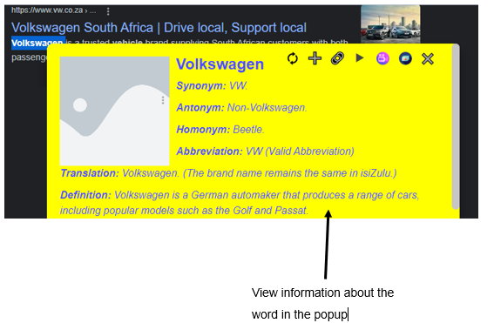

**Functionality of Each Button**

**✖️** - Close the popup

- View an image relating to the word

- View a video relating to the word

**▶ -** Hear how the word is pronounced

**🔗 -** Wiki link to the word

**➕ -** Move the popup around the page for better viewing

- Refresh the image to view another image

**Acknowledgements**

We would like to extend our heartfelt gratitude to OpenAI and Pexels API for their invaluable contributions to our Chrome extension.

OpenAI: We utilize the OpenAI API to enhance user experiences and provide comprehensive information within our extension as well as the image.

Pexels: The Pexels API enables us to incorporate high-quality videos, sourced from their extensive collection of royalty-free content. This enriches the visual experience and user engagement within our extension.

**Disclaimer**

Please note that some of the information presented within the popup may not be entirely accurate or up to date. Our extension relies on APIs to gather and provide data, and while we strive to ensure the reliability and accuracy of these sources, there may be occasional discrepancies or outdated information.